React OTP
Pluggable widget for Mendix Studio Pro 10.24.17
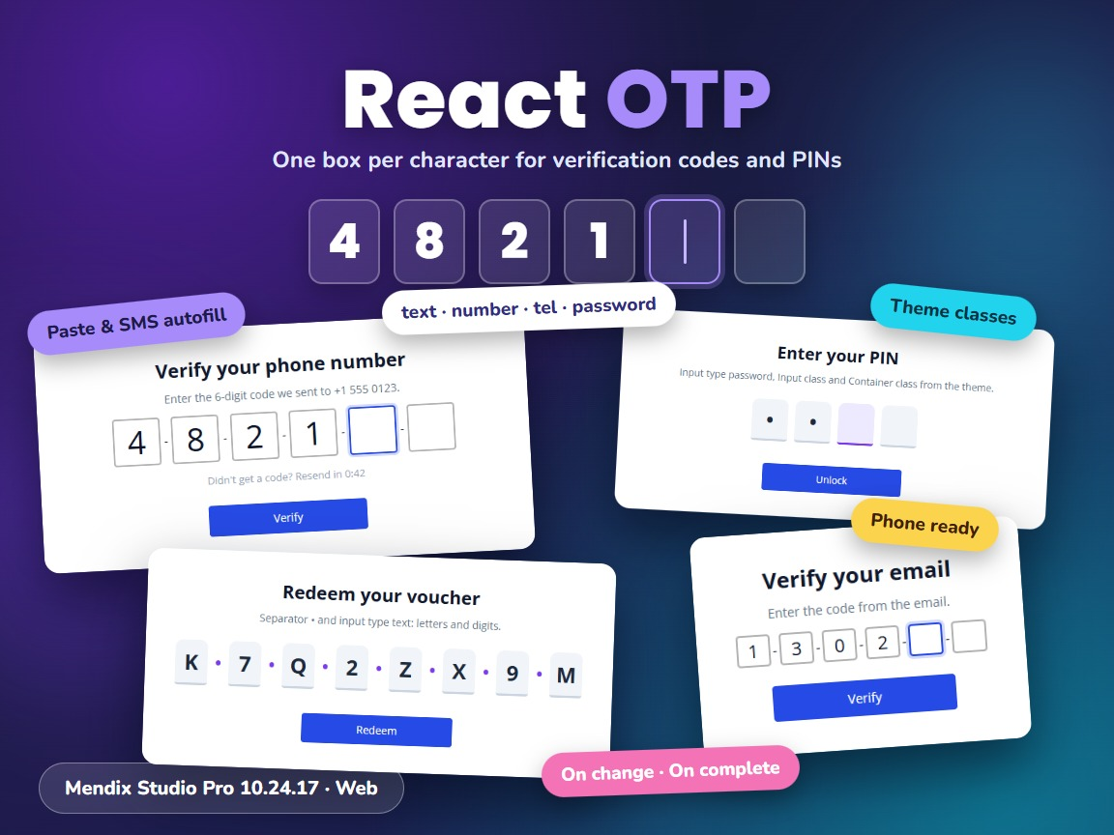
Item | Value
Widget version | 1.1.0
Studio Pro version | 10.24.17 (tested on 10.24.17.102810)
Widget ID | mendix.reactotp.ReactOTP
Widget package | mendix.ReactOTP.mpk (about 12 KB)
Platform | Web (offline capable)
OTP library | react-otp-input 3.1.1
Build tooling | @mendix/pluggable-widgets-tools 10.16.0
Source and downloads | github.com/bharathidas/ReactOTP

Contents

1. Overview
React OTP is an input for one-time passwords (OTP), verification codes and PIN codes. It shows one box per character. The cursor moves to the next box while the user types and back with Backspace, and a code that is pasted or offered by the phone is spread over the boxes.
The code is stored in a String attribute. The number of boxes, the input type (text, number, tel or password), the separator between the boxes and the placeholder come from attributes, so they can change at run time. Two events, On change and On complete, can run an action, for example to verify the code as soon as every box is filled.
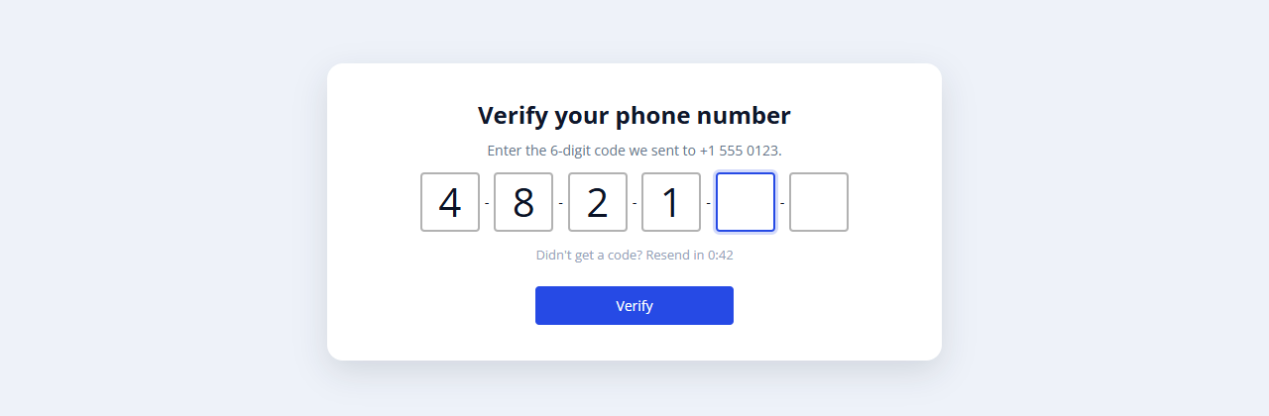
Figure 1. Six boxes with the default style while the user types the code

Typical uses
- Two-factor authentication and login with a code sent by SMS or email
- Verifying a phone number or email address during registration
- PIN entry, for example to unlock a page or confirm a payment
- Voucher, licence and invitation codes

2. What is new in version 1.1.0
- Rebuilt for Mendix Studio Pro 10.24.17 with @mendix/pluggable-widgets-tools 10.16.0 and react-otp-input 3.1.1, as a production build. The package is about 12 KB; version 1.0.0 was about 44 KB.
- Number of inputs, Input type and Separator are optional. In 1.0.0 they were required, so every page needed three extra attributes. Without them the widget shows 4 boxes of type text with - between them.
- An empty Number of inputs attribute (which Mendix passes as 0) shows 4 boxes. In 1.0.0 it showed no boxes at all. Values above 20 or below 1 also use 4.
- The input type ignores case and spaces ( PassWord is password); an unknown value uses text.
- Placeholder: one character is shown in every box (for example 0), a longer text gives one character per box. In 1.0.0 the placeholder was only used when its length was exactly the number of boxes; otherwise an error was written to the browser console.
- Read-only: when the attribute cannot be edited (Editability, a read-only data view or access rules), the boxes are disabled. In 1.0.0 they stayed enabled.
- New On change and On complete actions, and a new Auto focus option.
- The first box has autocomplete="one-time-code", so phones can offer the code from an SMS.
- A validation message for the attribute (from a microflow or nanoflow) is shown below the boxes.
- The default box style is now CSS (class widget-reactotp-input-default) instead of inline styles. It looks the same on a desktop, gets a focus colour and a light placeholder, and the boxes become smaller on phones so six boxes fit on a 375 px screen. In 1.0.0 six boxes ran off the screen.
- The class, style, tab index and Name (mx-name-… class) from Studio Pro are applied. In 1.0.0 they were ignored.
- No more debug messages in the browser console (1.0.0 wrote messages on every render).
- Studio Pro design mode shows four boxes. Clearer captions and descriptions. The property keys are unchanged, so existing pages keep their settings.
Version 1.1.0 was tested in a Mendix 10.24.17 app (41 automated checks): number of boxes, input types, separator, placeholder, typing, Backspace, arrow keys, paste, letters in a number box, a value changed elsewhere, read-only, On change, On complete, auto focus, custom classes, tab index and a phone-sized window. The screenshots in this document are from that test app.

3. Requirements
- Mendix Studio Pro 10.24.17 or a later 10.24 version.
- A web profile. The widget is not available for native mobile.
- The widget must be inside a data view (or another widget that gives an object). The object needs a String attribute for the code. No other modules are needed.

4. Installation

4.1 Install the widget
- Download mendix.ReactOTP.mpk from the Mendix Marketplace or from the GitHub release Version1.1.0.
- Copy the file into the widgets folder of your app. To find the folder, use App > Show App Directory in Explorer in Studio Pro.
- In Studio Pro, choose App > Synchronize App Directory (F4).
- The widget appears in the Toolbox as React OTP.

4.2 Upgrade from version 1.0.0
- Replace mendix.ReactOTP.mpk in the widgets folder with the 1.1.0 file.
- Synchronize the app directory (F4).
- Studio Pro reports that the widget definition has changed. Right-click the error and choose Update all widgets. Your settings are kept.
- If the running app still shows the old widget, stop it, choose App > Clean Deployment Directory, and run it again.
Check after upgrading: if you used Input class or Container class, your class now fully controls the boxes (1.0.0 also set an inline width of 1em on every box). Give the boxes a width in your class, as in the example in chapter 8. Without a class nothing changes on a desktop.

5. Configuration

5.1 Place the widget on a page
- Create (or use) an entity with a String attribute for the code, for example a non-persistent entity CodeHelper with the attribute Code.
- Put a data view on the page with an object of that entity, for example from a nanoflow that creates it.
- Drag React OTP from the Toolbox into the data view.
- On the General tab, select the Value attribute.
- Optional: select attributes for Number of inputs (Integer), Input type, Separator and Placeholder (String). Leave them empty for 4 text boxes with - between them.
- Optional: on the Events tab, select an On complete action that verifies the code, for example a microflow that compares it with the code you sent.

5.2 Recommended settings
Use | Settings
6-digit SMS or email code | Number of inputs 6, input type number, On complete: verify microflow
PIN | Number of inputs 4, input type password, Auto focus Yes
Authenticator app code | Number of inputs 6, input type tel, placeholder 0
Voucher with letters | Number of inputs 8, input type text, separator •
Show a code (no editing) | Editability Never

Number of inputs, Input type, Separator and Placeholder are attributes, not fixed values. Give them a default value in the domain model (for example 6 and number) or set them in the nanoflow that creates the object.

6. Property reference

General – Data source
Property | Type | Description (default)
Value | String attribute | The attribute that holds the code. Required.
Number of inputs | Integer attribute | Number of boxes, 1–20. Empty, 0 or out of range = 4.
Input type | String attribute | text, number, tel or password (case and spaces are ignored). number and tel accept only digits and show the number keyboard on phones. Empty or unknown = text.
Separator | String attribute | Text between the boxes. Empty = -.
Placeholder | String attribute | Shown in empty boxes: one character for every box (0) or one character per box (123456). Empty = no placeholder.

General – Appearance
Property | Type | Description (default)
Input class | Text | CSS class for each box. When set, it replaces the default box style. (empty)
Container class | Text | CSS class for the row of boxes. When set, it replaces the default row style (centered, 1rem margin). (empty)
Auto focus | Boolean | Puts the cursor in the first box when the page opens. (No)

General – Common, Editability, Visibility
Property | Type | Description
Name | System | Name of the widget; also gives the class mx-name-<name>.
Tab index | System | Tab index of the boxes.
Editability | System | Default, Never or Conditionally. When not editable, the boxes are disabled.
Visibility | System | Default or Conditionally.

Events
Property | Type | Description
On change | Action | Runs after the user changes the code (each typed, deleted or pasted character).
On complete | Action | Runs when every box is filled, for example to verify the code or go to the next page. It runs again when the user changes a character of a complete code.

7. Examples
Figure 2. Default style, six boxes, input type number
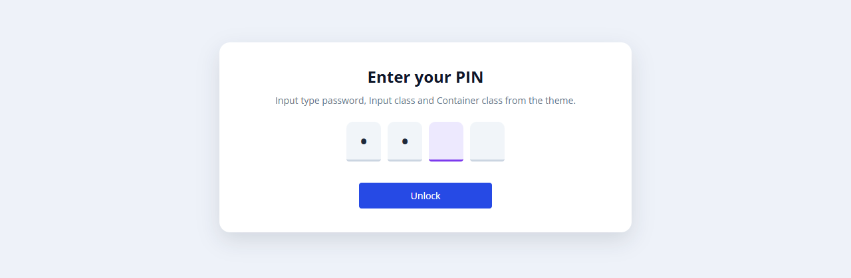
Figure 3. Input type password with Input class otp-box and Container class otp-row from the theme
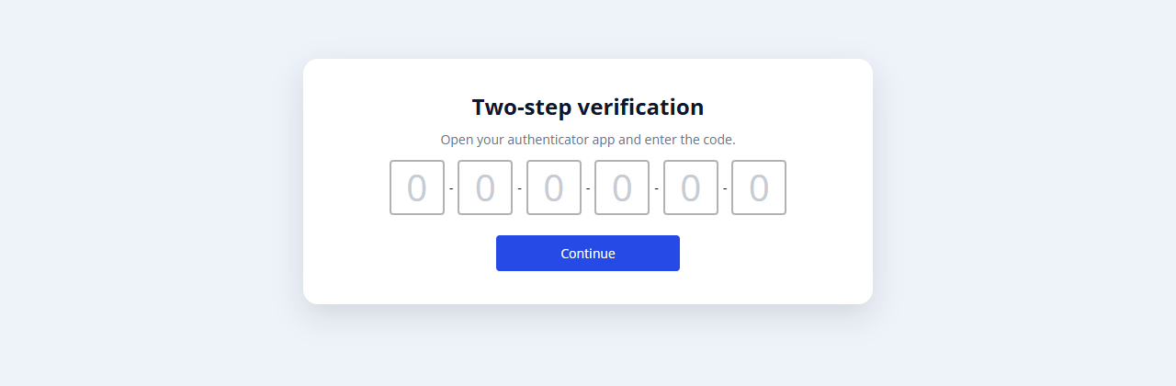
Figure 4. Placeholder 0 in every box
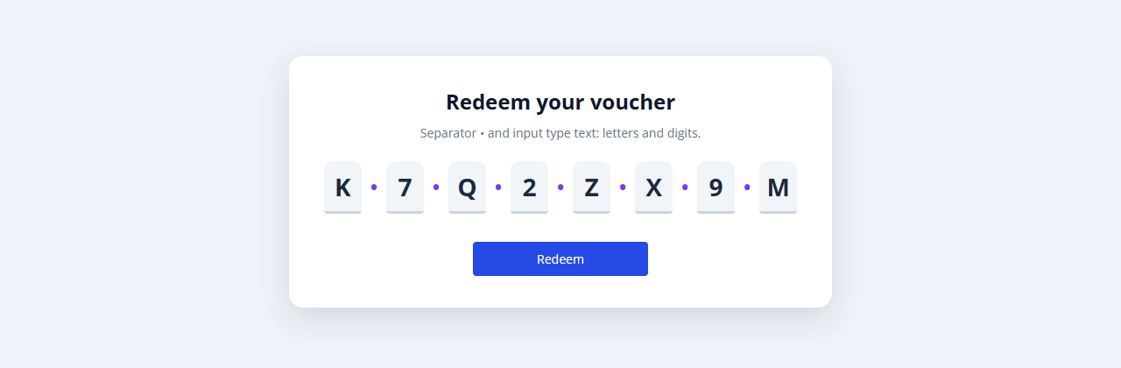
Figure 5. Eight boxes of type text with the separator •
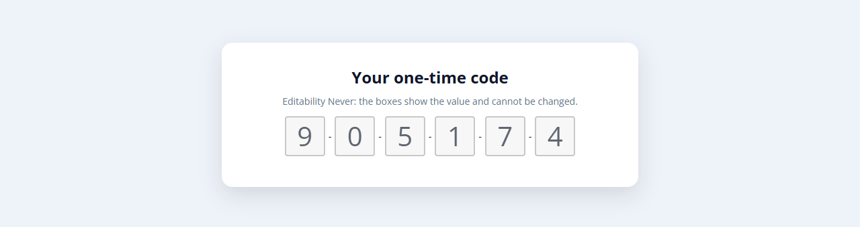
Figure 6. Editability Never: the boxes show the code and are disabled
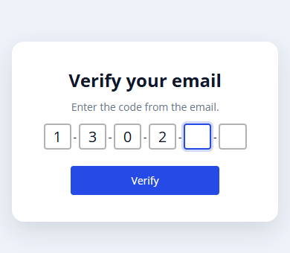
Figure 7. Phone width: the default boxes become smaller

8. Styling
The widget renders these elements. The class and style from the Appearance tab are applied to the outer element.
<div class="widget-reactotp mx-name-reactOTP1 your-class">
<div class="widget-reactotp-inputs widget-reactotp-inputs-default">
<input class="widget-reactotp-input widget-reactotp-input-default">
<span class="widget-reactotp-separator">-</span>
... one input per box ...
</div>
<div class="alert alert-danger mx-validation-message"> validation message </div>
</div>
When Input class is set, it replaces widget-reactotp-input-default; when Container class is set, it replaces widget-reactotp-inputs-default. The theme classes of screenshot 2:
.otp-row { display: flex; justify-content: center; gap: 10px; margin: 20px 0; }
.otp-row .widget-reactotp-separator { display: none; }
.otp-box { width: 52px; height: 60px; font-size: 28px; font-weight: 700; border: 0;
border-bottom: 3px solid #cbd5e1; border-radius: 10px 10px 4px 4px; background: #f1f5f9; }
.otp-box:focus { outline: none; border-bottom-color: #7c3aed; background: #ede9fe; }
To keep the default style and only change the colours, leave Input class empty and style .widget-reactotp-input-default in your theme.

9. Known behaviour and limitations
- Web only; not available in native mobile apps.
- When the user types in a box while earlier boxes are empty, the characters move to the front: the value is stored without gaps. This is how the react-otp-input library works.
- A value longer than the number of boxes is shown cut off; the attribute keeps the full value until the user changes it.
- Number of inputs, Input type, Separator and Placeholder are attributes (as in 1.0.0), not fixed values in the widget properties.
- The separator cannot be empty; an empty attribute shows -. Hide it with CSS (.widget-reactotp-separator { display: none; }) or use a space.
- SMS autofill depends on the phone and browser; the message must contain the code in a format the phone recognises.

10. Support and version history
Report issues, suggestions and feature requests on GitHub:
https://github.com/bharathidas/ReactOTP/issues
Source code and all releases:
https://github.com/bharathidas/ReactOTP
Widget | Studio Pro | GitHub release | Changes
1.1.0 | 10.24.17 | Version1.1.0 | Rebuilt for Studio Pro 10.24.17; optional number of inputs, input type and separator; empty number of inputs shows 4 boxes; placeholder per box or for all; read-only support; On change and On complete; auto focus; SMS autofill; validation message; responsive CSS; class, style and tab index applied; no debug logging; design-mode preview.
1.0.0 | 9.12.4 | version1 | First release.

